HTTP
/ip proxy set anonymous=yes
/ip proxy set enabled=yes port=8080 cache-administrator=bintang@smkpgriwlingi.sch.id
/ip proxy set max-cache-size=unlimited

/ip proxy access add dst-host=detik.com action=deny comment="detik.com"

/ip firewall nat add chain=dstnat protocol=tcp dst-port=80 in-interface=ether3 action=redirect to-ports=8080 comment="Redirect HTTP ether3"
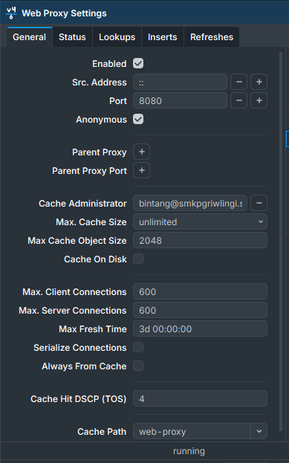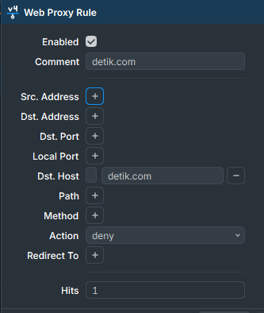
HTTPS
/ip firewall filter add chain=forward protocol=tcp in-interface=wlan1 content=detik.com action=drop comment="detik.com on wlan1"
